November 2019

Monon Trail

Elementary School PTO







[This Photo](http://firstgradefactory.blogspot.com/2011_11_01_archive.html) by Unknown Author is licensed under [CC BY-NC-ND](https://creativecommons.org/licenses/by-nc-nd/3.0/)

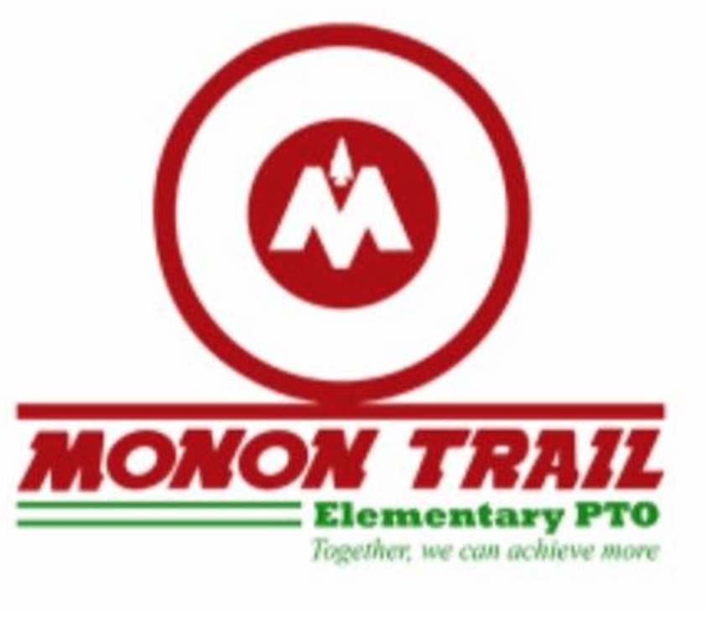

2019 – 2020 PTO Calendar

Contact Information

### **In this Issue!**

What an exciting time it’s been here at Monon! We kicked off Fall with our largest Fundraising Event -Fall Festival! All funds raised from the activity tickets and silent auction items go directly to those teachers for classroom supplies. Thank you to all Volunteers, Teachers & Staff, MTES families, and friends who came out to support and make this year’s event a great success!



We wrapped up October with our All School Movie Night featuring –Toy Story 4. Thank you to all who made this night a success!



# **Happy Fall Monon Trail Elementary!**

# November Events

## **FALL ROOM PARTIES**

## Friday, November 1st @ 1:40 pm

Students get to enjoy snacks, crafts, and games celebrating the fall season! A huge THANK YOU to all the Room Leads & Parent Volunteers for organizing these great and memorable parties! Room Parent Leads can contact

Melisa Lufkin at 508-314-8913 or email [mtespto@gmail.com](mailto:mtespto@gmail.com) with any questions.

**Book Fair -** The book fair will run from **November 11th to November 22nd**.  We need parent volunteers to help!  Use the signup genius link below.

[**https://www.signupgenius.com/go/30E0C49ACAF2BA4F58-book1**](https://www.signupgenius.com/go/30E0C49ACAF2BA4F58-book1)

## 

**\*Family Fast Night November 12th 6:00pm -7:30pm Book Fair Open from 5:30p-8:00p**

**Come out for an evening of fun as you and your family challenge each other in one of our 3 family challenges and 6 Activity Stations set up in the Gym! Hope to see you there! \***



**Calling all MTES Active Duty/Veteran's**

We would love for you to participate in our Veteran's Day program on Friday November 15th at 8:15 am. Our 4th grade students would love to sit in small groups with you and ask questions to learn about what it means to serve our country.

**Please email: mtespto@gmail.com if you are interested in participating.**

The staff and students would be grateful!

**This event is for the 4th grade students only**



**Washing Family T-shirts**

**Looking for a way to volunteer? Check this out!**

**\*\*Dates listed are drop off by dates\*\***

<https://www.signupgenius.com/go/30E0C49ACAF2BA4F58-washing>

**SAVE THE DATE!**

**SPRING School Night | Indiana Pacers -**

**Friday, January 17th vs. the Minnesota Timberwolves at 7:00pm.**

**\*\*More information to come in December!**



# November Events

# November Events

## 

## **PTO MEETING**

## November 18th at **6:30pm**

## **Dr. Grate – Growing The Rock Way– 6:45p**



**Growing the Rock Way**

Westfield is experiencing rapid growth and WWS has a vision and a plan! Growing the Rock Way is a presentation that walks through that plan and shows what the next 5 years looks like for the school district. MTES PTO is excited to have WWS Superintendent Dr. Sherry Grate sharing the Growing the Rock Way presentation with us at our next PTO Meeting!

Registration for winter clubs will begin in December

There will be 2 winter sessions:

January 13th - January 31st (it’s a 3 week session with clubs meeting twice a week)

February 10th - March 20th (6 week session)

**Email:** [**mtespto@gmail.com**](mailto:mtespto@gmail.com) **Website: MTESPTO.com Facebook: MTES PTO**

**2019-2020**

**PTO Calendar**



**August**

4th–Back to School Night

12th–Meet the Teacher Night

13th–PTO Meeting 6:00 PM

16th–Deadline for Corporate Sponsors

28th–MTES Night @ Cone & Crumb

**September**

10th–PTO Meeting 3:00PM

10th - No Cook Night-Chipotle

9th–13th-Monon Moves Week/

Walk-a Thonon Friday9/13

26th–Homecoming Parade

**October**

4th–FALL FESTIVAL

9th–No Cook Night-Noble Romans

25th–Movie Night

29th – Shop to Support Evereve @ Clay Terrace

**November**

1st–Fall Parties

5th–No Cook Night –Greeks Pizza

11th–Book Fair

12th –STEM, Sports Night

15th–Veteran’s Day Celebration

18th **–** PTO Meeting 6:30 PM -

**6:45 Dr. Grate – Growing Rocks Way**

19th–Staff Luncheon

**December**

3rd –3rd& 4thGrade Music Performance @ WHS

7th–Barnes & Nobles

10th–Staff Luncheon

11th–No Cook Night–Hot Box Pizza

**December Cont.**

19th – Class Parties

20th – Sing Along

21st – Winter Parties

**January**

14th- PTO Meeting 6:30 PM

24h – Movie Night

**February**

11th – PTO Meeting 3:00 PM

13th – Valentine Parties

25th – Staff Luncheon

3rd and 4th grade musical TBD

**March**

10th – PTO Meeting 6:30 PM

16th – Book Fair

19th Community Helper Night (Kindergarten)

26th – Fine Arts Night

**April**

14th – PTO Meeting 3:00 PM

21st – No Cook Night

**May**

8th – Kindy 500

11th-15th Staff Appreciation Week/ Staff Luncheon

15th – Field Day

1st and 2nd grade informances TBD

Talent Show TBD

# Big Ways You Can Help!

## A close up of a logo Description automatically generatedShop Amazon using AmazonSmile

If you want Amazon to donate to MTES PTO then start each shopping session at <https://smile.amazon.com>. We earn 0.5% of eligible purchases when you shop.

## Collect Box Tops

It’s so EASY Go online line to register! [www.boxtops4education.com](http://www.boxtops4education.com) The first class to reach $500 wins a pizza party!

## Sign up for Community Rewards & Shop at Kroger

Register your Kroger Plus Card to Monon Trail Elementary School and a percent of everything you spend is donated to the school. This provides approximately $4,000 a year!

## 

## **MTES Family Sponsorships**

## Every dollar matters!  Thank you for becoming a family sponsor of Monon Trail Elementary.  No donation is too small.  If every family were able to donate $20 a child we would reach our $10, 000 goal.  We understand that not every family is able to donate, but if it fits within your family budget would you considering making a contribution?  Together we can fully fund our programming and classroom needs.  You can donate online (at [mtespto.com](http://mtespto.com/)) or send in cash/check with your child. (checks should be made out to Monon Trail Elementary PTO)

**Email:** [**mtespto@gmail.com**](mailto:mtespto@gmail.com) **Website: MTESPTO.com Facebook: MTES PTO**



**Silver Sponsors:**

Williams Custom Art Builders

Union Street Flats – J.C. Hart Community

Leadjen

Vivirito Realty Group

AutoFarm

Rangeline Chiropractic

Old Town Design Group

Meijer

Westfield Powersports

ProX

**Gold Sponsors:**

Chatham Hills

Riverview Health

New Beginnings Family Counseling- Mary Holland

Century 21 Kristin Burgunder

G&G Homes

Wesley’s Landscaping

Thurston Springer

Stone Center

Indy Home Pros

Wittler Orthodontics

Stanley Morgan (Joe Copeland, Ben Donathen)

Gorman & Bunch

Thank you to our sponsors!

**Platinum Sponsor:**

Northview Church

**President:** Carrie Woodruff (317) 250-7618

**Co Vice President:** Tricia Williams

**Treasurer:** Kate Ellis

**Secretary:** Stephanie Addington

**Email:** mtespto@gmail.com

**Facebook:** MTES PTO

**Website:** www.mtespto.com

# **Contact Information:**

**Email:** [**mtespto@gmail.com**](mailto:mtespto@gmail.com) **Website: MTESPTO.com Facebook: MTES PTO**